Garth Bates

11473063

9/23/21

Project 2 Report

1. Overview
   1. We are building a traffic light system.
   2. We will use the Laucnhpad and breadboard for a prototype
   3. Garth -> Coding
   4. Launchpad powered by USB
2. Functional Description
   1. The LED will green on start up. When a pedestrian arrives (switch 2 is pressed) the LED will turn yellow, then after a delay turn red. When a car arrives (switch 1 is pressed) the LED will return to green.
   2. Hardware and software will be included on turnin date
   3. Launchpad, electronic, breadboard
   4. Pedestrian -> yellow light -> red light, car -> green light correctness.
   5. Activation switches
   6. Electronics maintenance
3. Deliverables
   1. Traffic light system based on the TM4C and electronics.

Flow Diagram

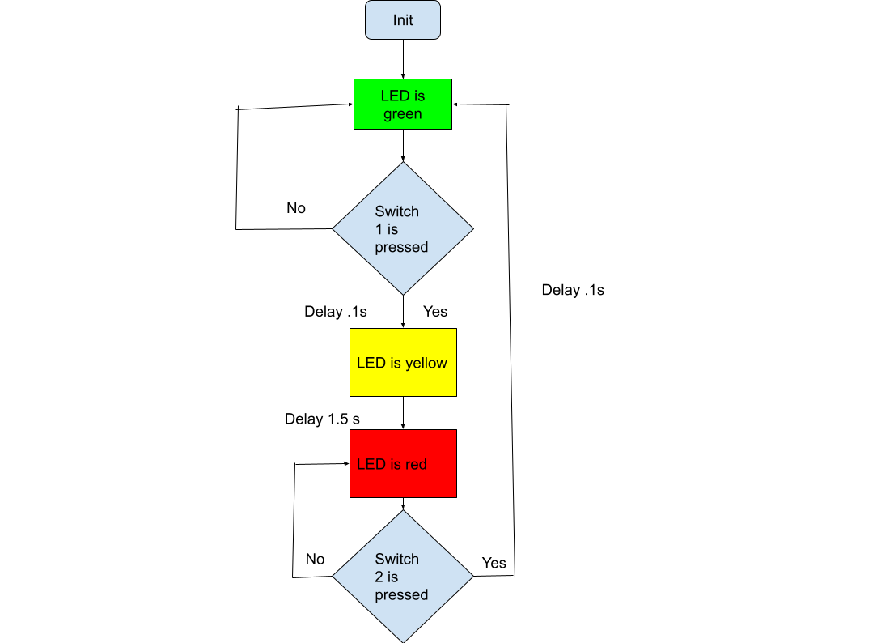

Data Flow Graph

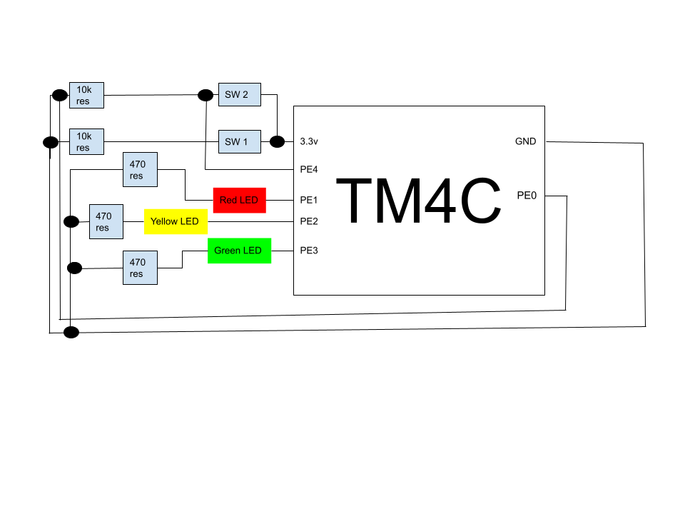

I used the delay function from project one. I multiplied the time by 15 to give me 1.5 seconds for the yellow light and left the default delay of .1 second for switching from green to yellow and red to green. Most of my challenges came from the actual building of the breadboard. Once I got the board built my next biggest challenge was setting all the pins for input or output properly. After that was set up, the actual programming of the board was really straightforward. The amount of wires going every which way make the board quite unwieldy and hard to discern. If this were an actual light system a new board would have to be made with the proper circuits built in.